Meeting Agenda

**Date:** July 11, 2019 **Time:** 0930 **Location:** TBD

Attendees: Mr. Fontaine, Simona Babiceanu, Joseph Keogh

* **Plan (Where are we in the process)**

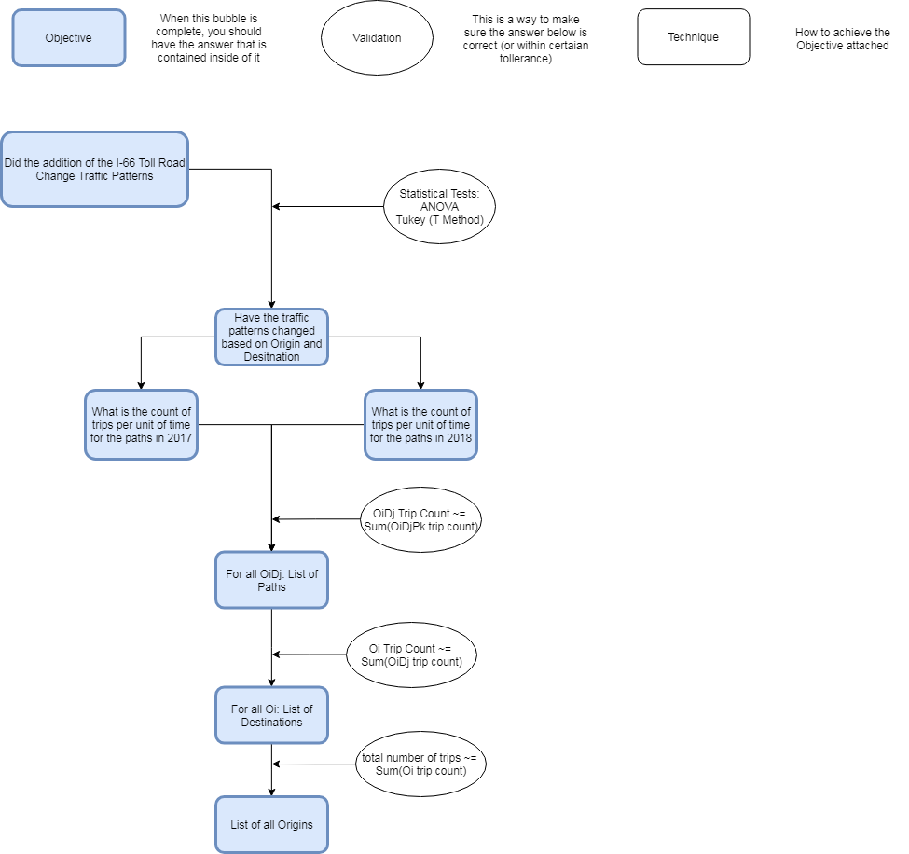



* Deliverables From Last Time
  + Visualize Data
    - Tableau Set up on computer
    - See Tableau Print Outs
  + Add outbound to area of interest
    - Complete
  + Adjust Grid to not Include MD
* Other Tasks Completed
  + Rivanna up and running
    - Github set up
    - Computer talks to Rivanna
  + UTC Date times fixed
    - View entire day traffic
  + Can now see proportion of node distribution
    - See Analysis Print Outs
  + Path counts
    - See Analysis Print Outs
* Findings
  + In ‘tripsDetected’ multiple of same TripID
  + Some paths have huge amount of traffic
    - This might be due do something else
      * The path outputs are weird
* Questions
  + Getting trip names with the same road in it
  + what should the cutoff be
    - See Risk Analysis Visual
* Next Steps
  + Better path analysis
    - How?
  + Statistical Analysis start
    - What will end output look like
  + Adjust OD Map
    - See what happens to percentages
  + Separate Tableau for inbound and outbound
  + Get accurate count data – from Rivanna